BMW Sales Analysis Using SQL
1. Introduction
Data analysis plays an important role in understanding business performance. In the automobile industry, companies analyze sales data to understand demand, customer preferences, and regional market trends. This project focuses on analyzing BMW car sales data using SQL queries. The dataset contains information about BMW models, sales year, month, region, units sold, revenue generated, average price, and BEV (Battery Electric Vehicle) share.
2. Project Objective
- The main objectives of this project are:
- To calculate total BMW car sales and revenue.
- To identify top-selling BMW models.
- To analyze regional sales performance.
- To understand monthly and yearly sales trends.
- To evaluate the growth of electric vehicles using BEV share.
3. Tools and Technologies Used
- SQL – Used to query and analyze the dataset.
- MySQL – Database management system used to store and manage data.
- BMW Sales Dataset – Contains information related to BMW sales.
4. Database Creation
The following SQL commands were used to create and access the database:
CREATE DATABASE project;
USE project;
5. Dataset Description
The table used in this project is named 'BMW'. It contains the following columns:
- Model – Name of the BMW car model
- Year – Year of sale
- Month – Month of sale
- Region – Sales region
- Units_Sold – Number of cars sold
- Revenue_EUR – Revenue generated in Euros
- Avg_Price_EUR – Average price of the car
- BEV_Share – Percentage share of electric vehicles
6. SQL Queries Used in the Project
- SELECT * FROM BMW;
Explanation: Displays all records and columns from the BMW table.
- SELECT SUM(Units_sold) AS total_sales FROM BMW;
Explanation: Calculates the total number of units sold using the SUM() function.
- SELECT SUM(Revenue_EUR) AS total_revenue FROM BMW;
Explanation: Calculates the total revenue generated from BMW sales.
- SELECT * FROM BMW WHERE Year BETWEEN 2019 AND 2020;
Explanation: Filters and shows records where the year is between 2019 and 2020.
- SELECT DISTINCT(Model) FROM BMW;
Explanation: Displays unique BMW models by removing duplicate values.
- SELECT AVG(Avg_Price_EUR) FROM BMW;
Explanation: Finds the average price of BMW cars.
- SELECT COUNT(Model) FROM BMW;
Explanation: Counts the total number of model records in the table.
- SELECT SUM(Avg_Price_EUR) AS total_sales FROM BMW;
  - Explanation: Adds all average price values together.
- SELECT Model FROM BMW WHERE Units_Sold > 500;
Explanation: Shows BMW models where units sold are greater than 500.
- SELECT Region, SUM(Units_Sold) AS total_unitsold FROM BMW GROUP BY Region;
Explanation: Groups sales by region and calculates total units sold in each region.
- SELECT Model, SUM(Revenue_EUR) AS total_revenue FROM BMW GROUP BY Model;
Explanation: Calculates total revenue generated by each BMW model.
- SELECT Model, SUM(Units_sold) AS total FROM BMW GROUP BY Model ORDER BY total DESC LIMIT 5;
Explanation: Finds the top 5 selling BMW models based on total units sold.
- SELECT Year, AVG(Revenue_EUR) AS average_revenue FROM BMW GROUP BY Year;
Explanation: Calculates the average revenue for each year.
- SELECT MAX(Avg_Price_EUR) AS maximum, MIN(Avg_Price_EUR) AS minimum FROM BMW;
Explanation: Finds the highest and lowest BMW car prices.
- SELECT Month, SUM(Units_Sold) AS monthly_sales FROM BMW GROUP BY Month;
Explanation: Calculates total units sold for each month.
- SELECT Year, AVG(BEV_SHARE) AS average FROM BMW GROUP BY Year;
Explanation: Calculates average BEV (electric vehicle) share per year.
- SELECT Region, SUM(Units_Sold) AS highest_unit FROM BMW GROUP BY Region ORDER BY highest_unit DESC LIMIT 1;
Explanation: Finds the region with the highest units sold.
- SELECT Model, Region, SUM(Units_Sold) AS topmodel FROM BMW GROUP BY Region, Model ORDER BY Region, topmodel DESC;
Explanation: Shows the top-selling model in each region.
- SELECT Month, SUM(Units_Sold) AS monthly_sales FROM BMW GROUP BY Month ORDER BY Month, monthly_sales DESC;
Explanation: Displays monthly sales sorted by month and sales value.
- SELECT Year, AVG(BEV_Share) AS peryear FROM BMW GROUP BY Year;
Explanation: Calculates BEV share for each year.
- SELECT Region, SUM(BEV_Share) AS highest FROM BMW GROUP BY Region ORDER BY highest DESC;
Explanation: Finds the region with the highest BEV share.
- SELECT Region, SUM(Units_Sold) AS top FROM BMW GROUP BY Region ORDER BY top DESC;
Explanation: Ranks regions based on total units sold.
- SELECT Year, SUM(Revenue_EUR) AS highest FROM BMW GROUP BY Year ORDER BY highest DESC;
Explanation: Shows total revenue generated in each year.

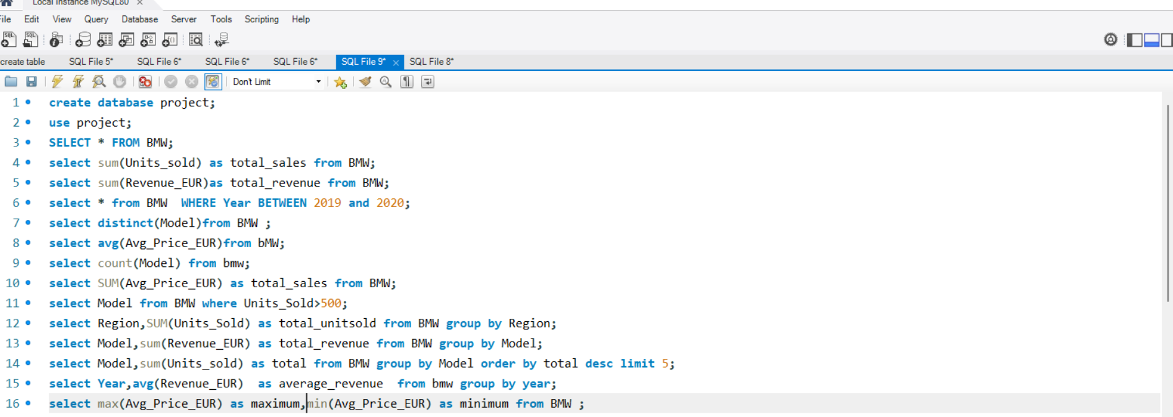

7. Key Findings
- The dataset shows that certain BMW models consistently sell more than others.
- Regional analysis helps identify which areas generate the highest sales.
- Monthly analysis reveals peak selling periods.
- Yearly revenue analysis shows overall business performance trends.
- The BEV share analysis indicates the increasing importance of electric vehicles.
8. Conclusion
This project demonstrates how SQL queries can be used to analyze real-world business data. Using SQL functions such as SUM, AVG, COUNT, GROUP BY, and ORDER BY, we were able to extract meaningful insights from BMW sales data. This type of analysis helps businesses make better strategic and data-driven decisions.

